**PRACTICUM REPORT**

**ALGORITHM AND DATA STRUCTURES**

**MODUL 2 : GETTING TO KNOW OOP IN PYTHON**



**Disusun Oleh :**

**ONIC AGUSTINO**

**L200234275**

**X**

**INFORMATICS ENGINEERING**

**FACULTY OF COMMUNICATION AND INFORMATICS**

**UNIVERSITAS MUHAMMADIYAH SURAKARTA**

**YEARS 2024/2025**

**2.11 Questions**

1.In Example 2.2, we have created a Message class that contains several methods. Add the methods below to that class.

(a) Method for checking whether a string is contained in the

Message object. This is the result:

>>> p9 = Pesan(’Indonesia adalah negeri yang indah’)

>>> p9.apakahTerkandung(’ege’)

True

>>> p9.apakahTerkandung(’eka’)

False

(b) Method for counting the number of consonants.

>>> p10 = Pesan(’Surakarta’)

>>> p10.hitungKonsonan()

5

(c) Method for counting the number of vowels.

>>> p10.hitungVokal()

4

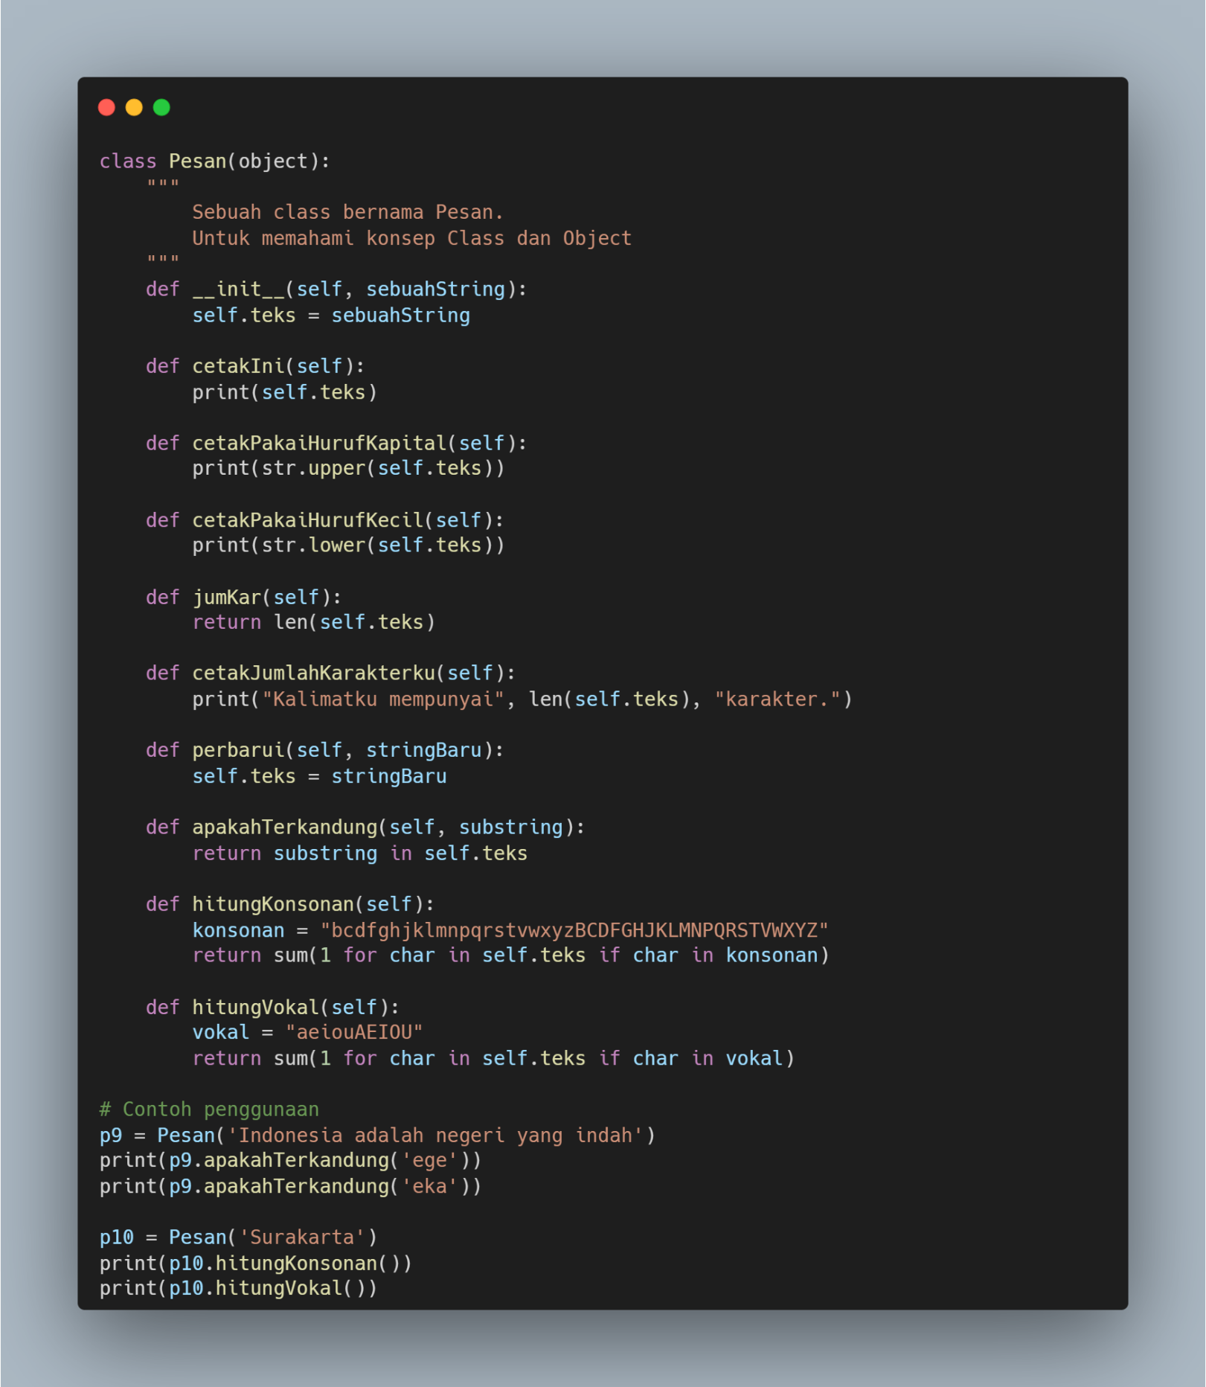

Picture 1.1 the code.



Pictrue 1.2 the output.

1. Look again at example 2.4. Add some methods as described below

(a) Method for retrieving the student's city of residence. This is the

result:

>>> m9.ambilKotaTinggal()

’Surabaya’

(b) Method for updating residential city. This is the result:

>>> m9.perbaruiKotaTinggal(’Sleman’)

>>> m9.ambilKotaTinggal()

’Sleman’

(c) Methods for increasing pocket money. This is the result:

>>> m7.ambilUangSaku()

270000

>>> m7.tambahUangSaku(50000)

>>> m7.ambilUangSaku()

320000

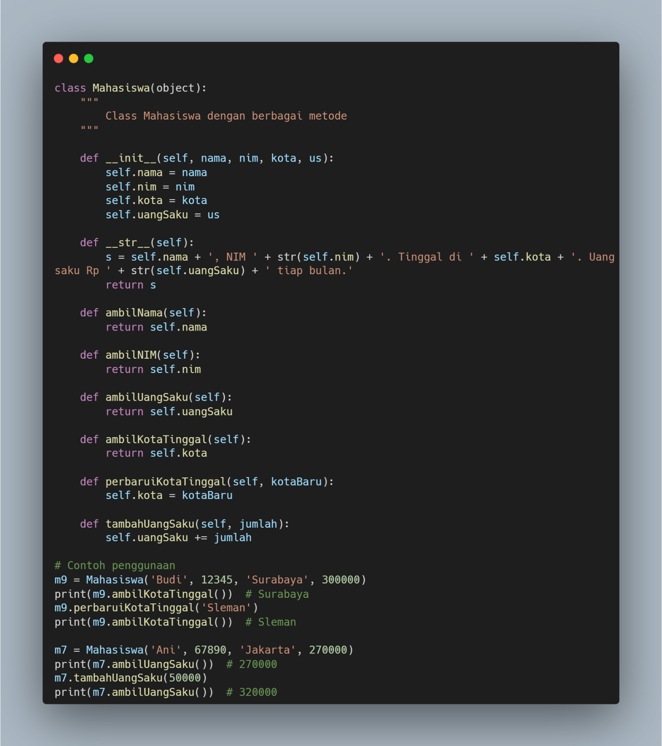

Picture 2.1 the code.



Picture 2.2 the output.

1. Still in example 2.4. Write a program to enter new student data via

Python Shell interactively. As you might have guessed, use

raw_input().

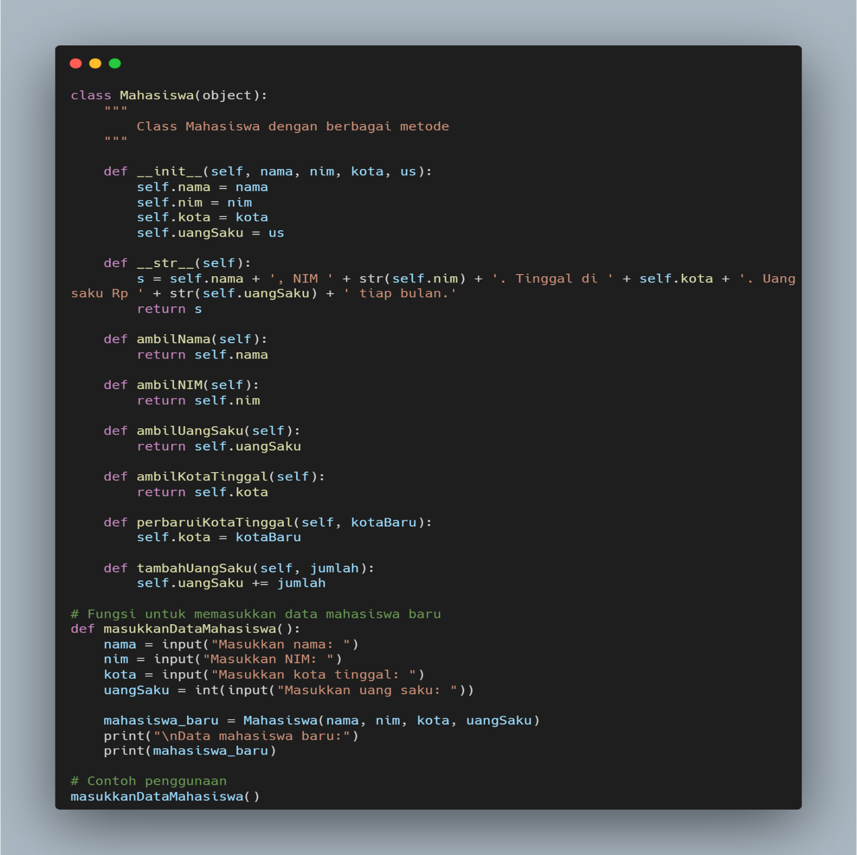

Picture 3.1 the code.

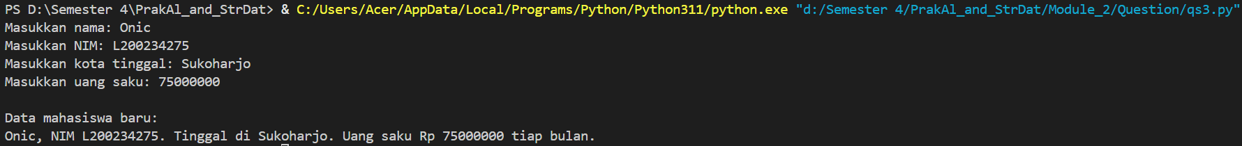

Picture 3.2 the output.